Module Name:Login Page - Functional & UI Test Cases
Test Case ID:st_01
Environment Information:OS: Windows 11, Browser: Chrome, URL: https://practice.expandtesting.com/login

Scenario: log in with valid credentials
Test Steps:
- Enter username:
- Enter Password:
- Click on login:
screenshot:
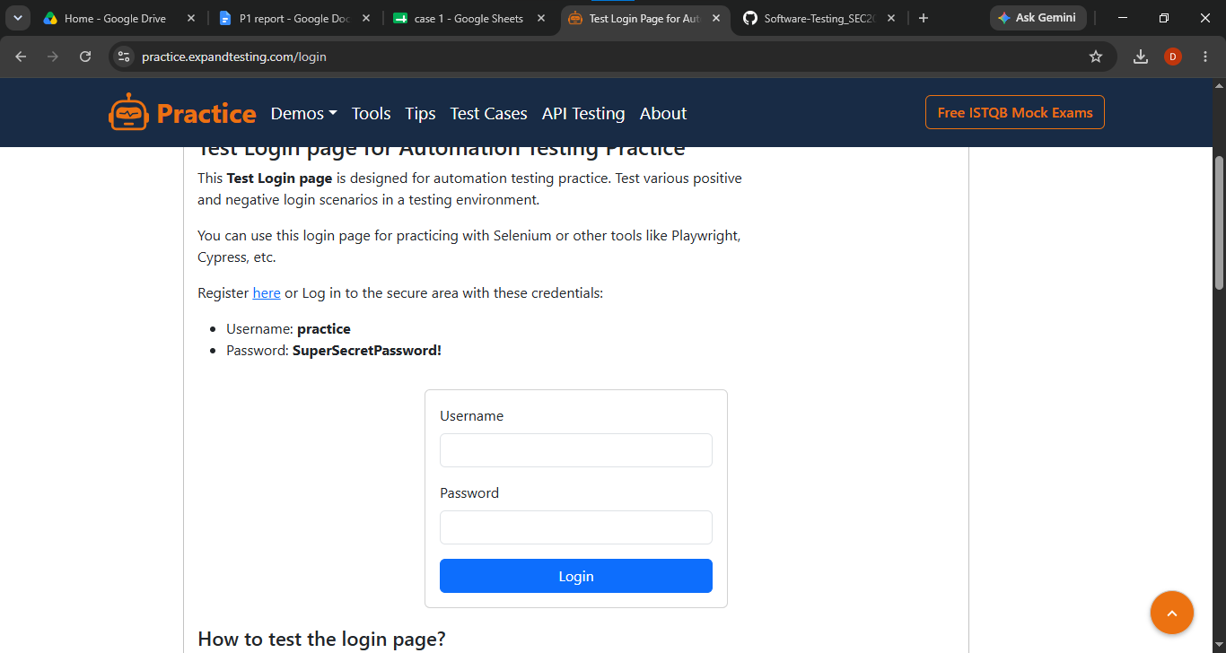

- Scenario ID: 1a
- Scenario: Login with valid credentials
Test step:
- Enter valid Username (practice)
- Enter valid Password (SuperSecretPassword!)
- Click Login
Screenshot
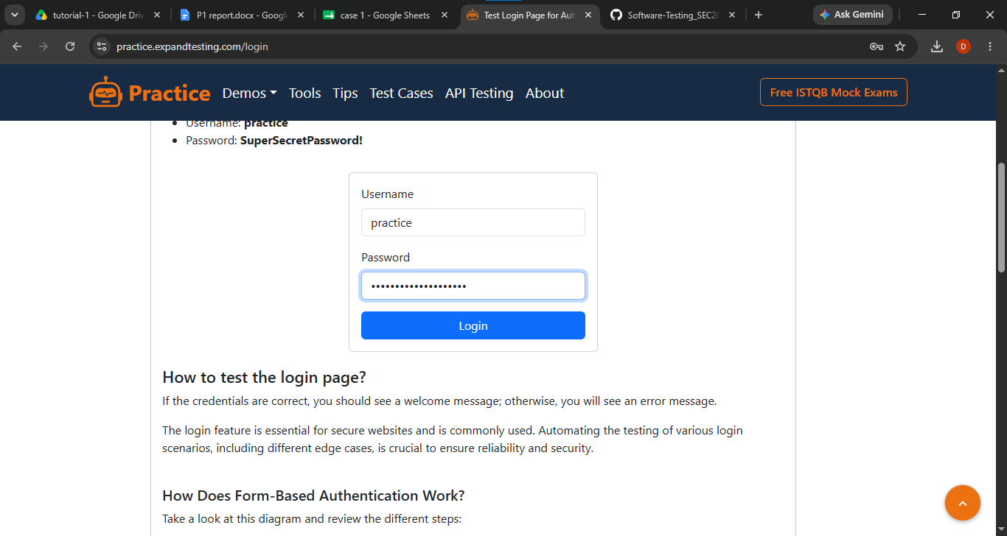

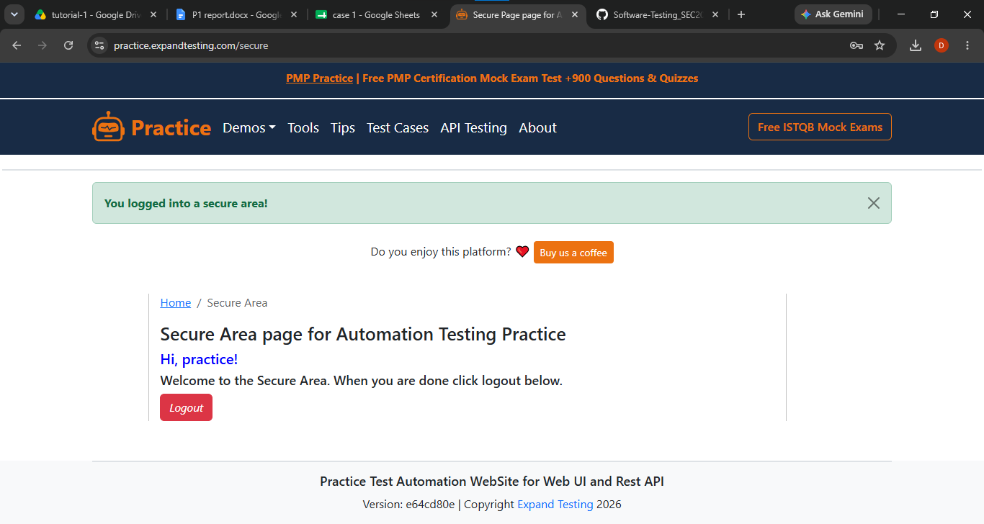

- Scenario ID: 1b
- Scenario:Login with invalid username
Test step:
- Enter invalid username
- Click on login

Screenshot:
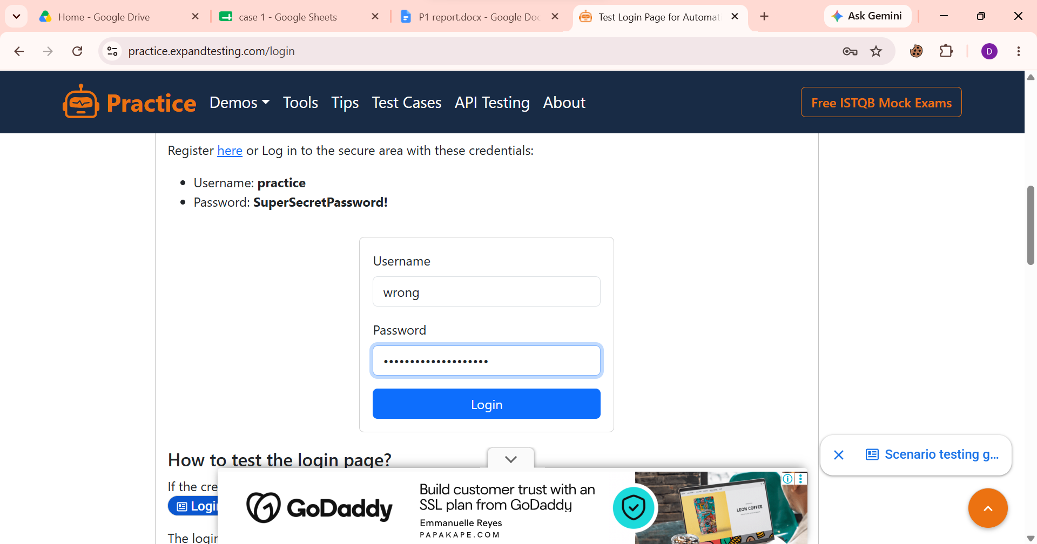
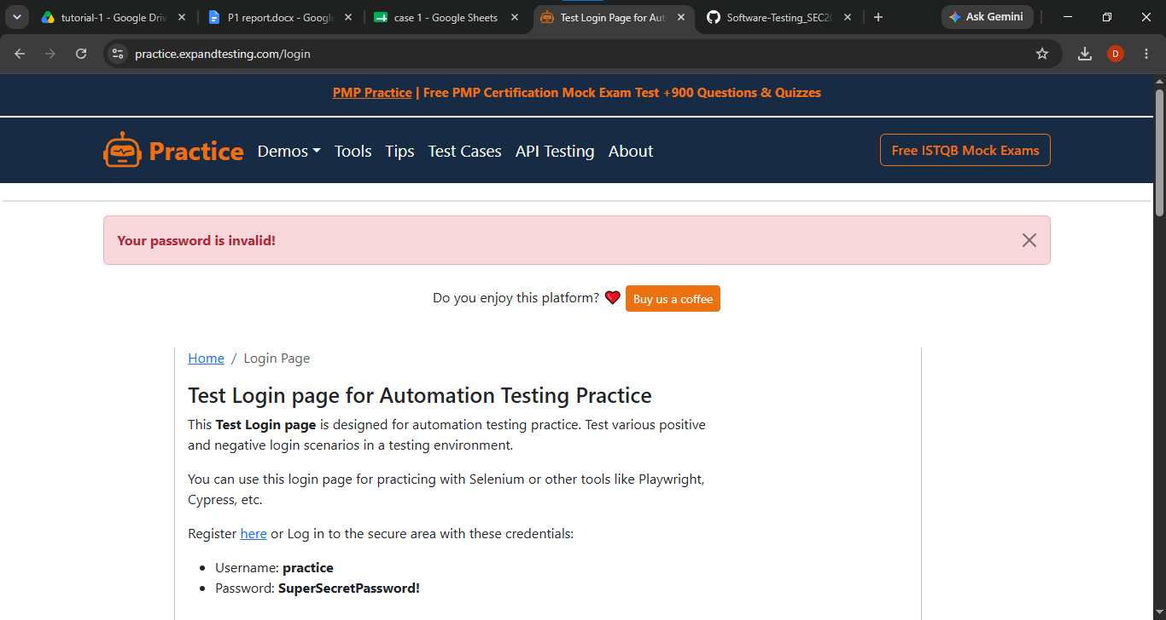

- Scenario ID: 1c
- Scenario:Login with invalid password

Test step:

1.Enter valid Username (practice)
2.Enter invalid Password (wrong123)
3.Click Login

Screenshot:
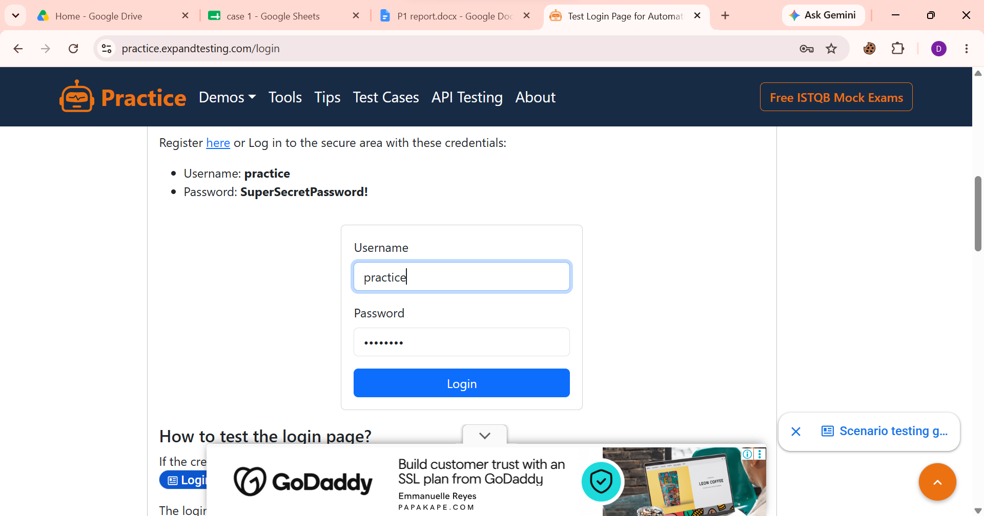
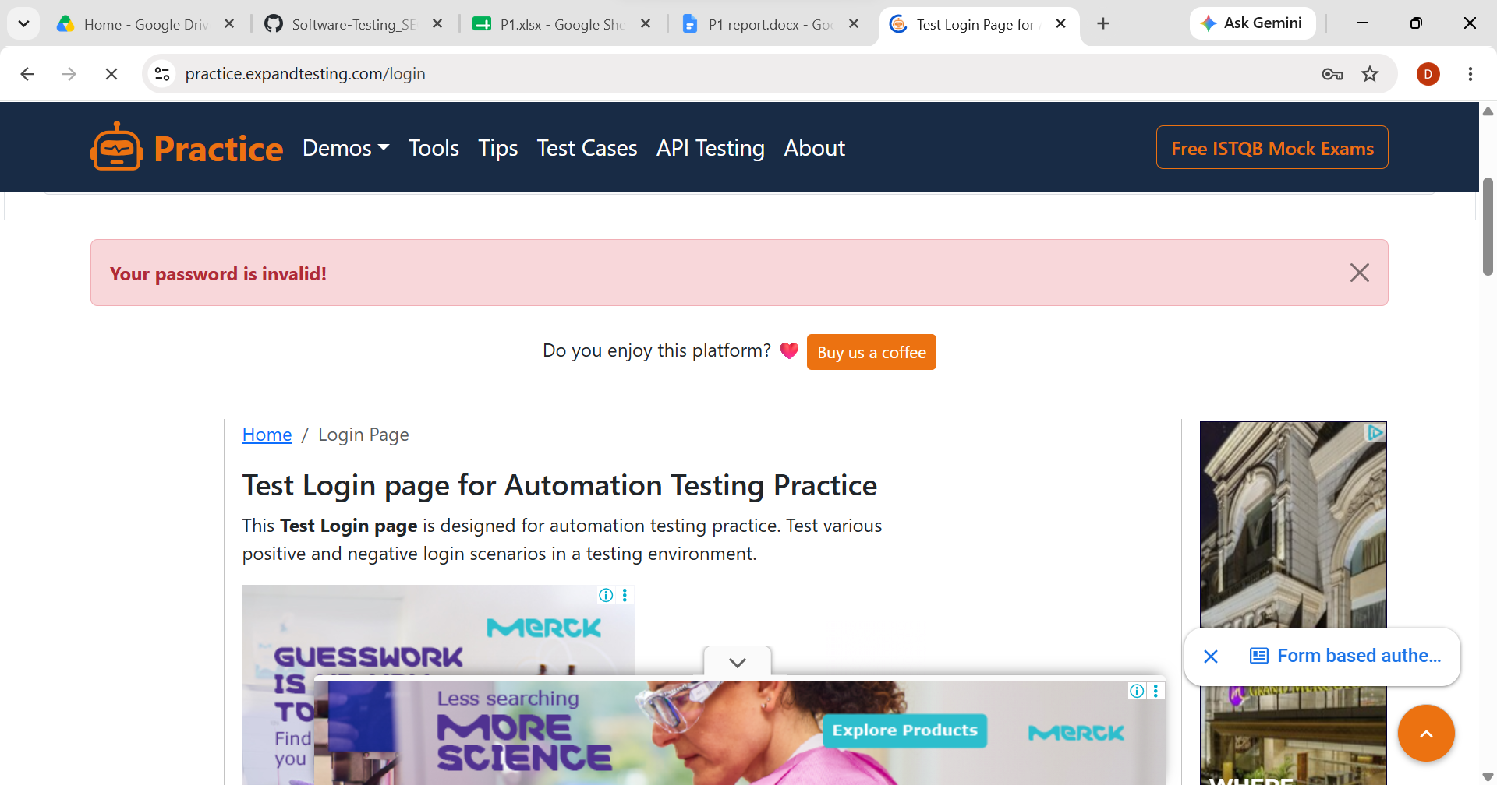
- Scenario ID: 1d
- Scenario:Login with both invalid credentials
Test step:

1.Enter” wrong” username and “wrong123” password
2.Click on login
Screenshot:

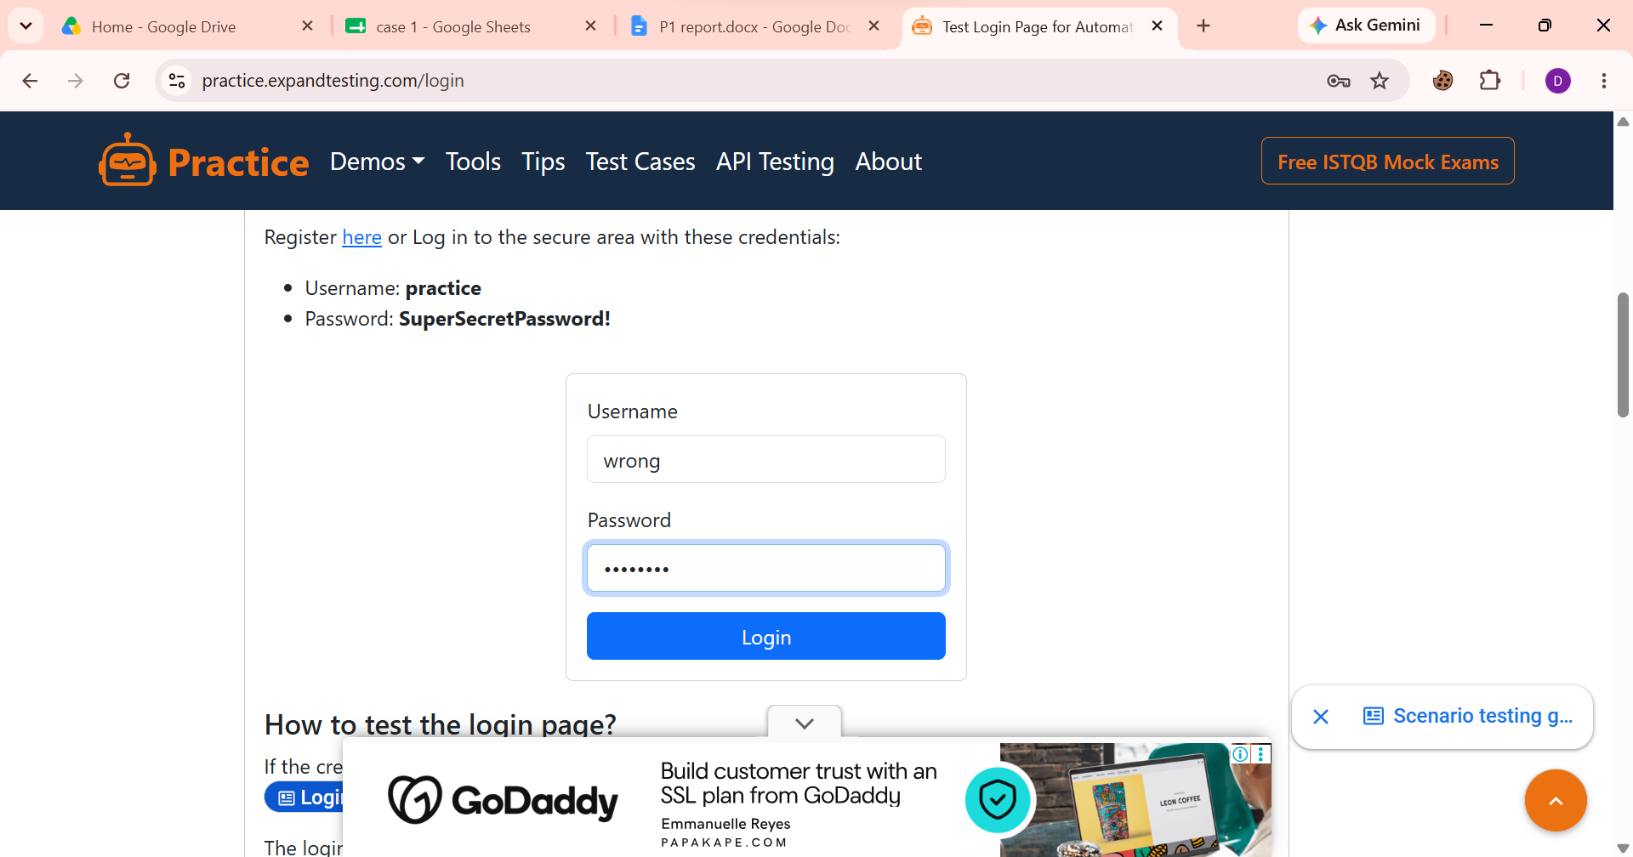
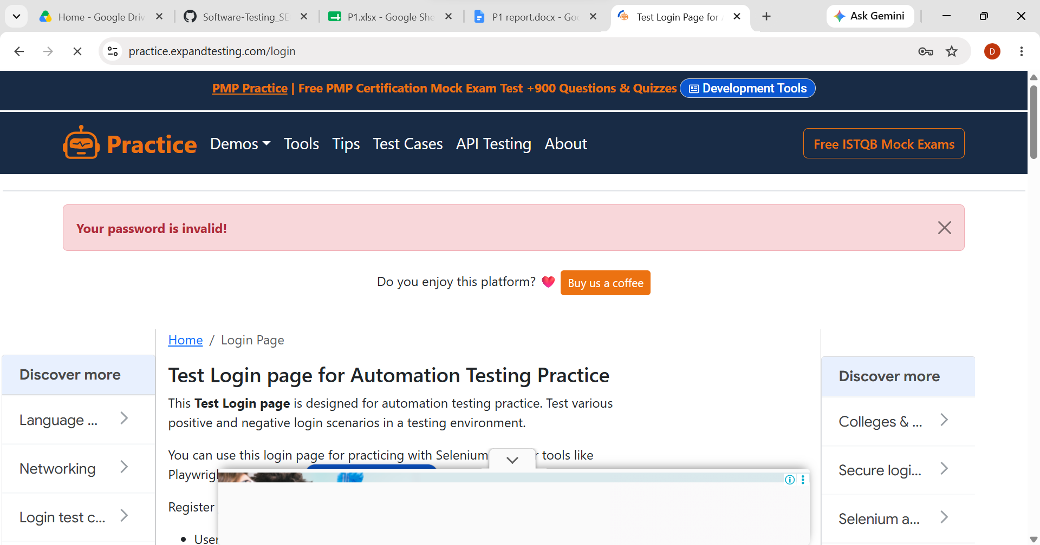
- Scenario ID: 1e
- Scenario:Login with empty fields
Test step:

1.Leave username & password blank
2.Click on login
Screenshot:
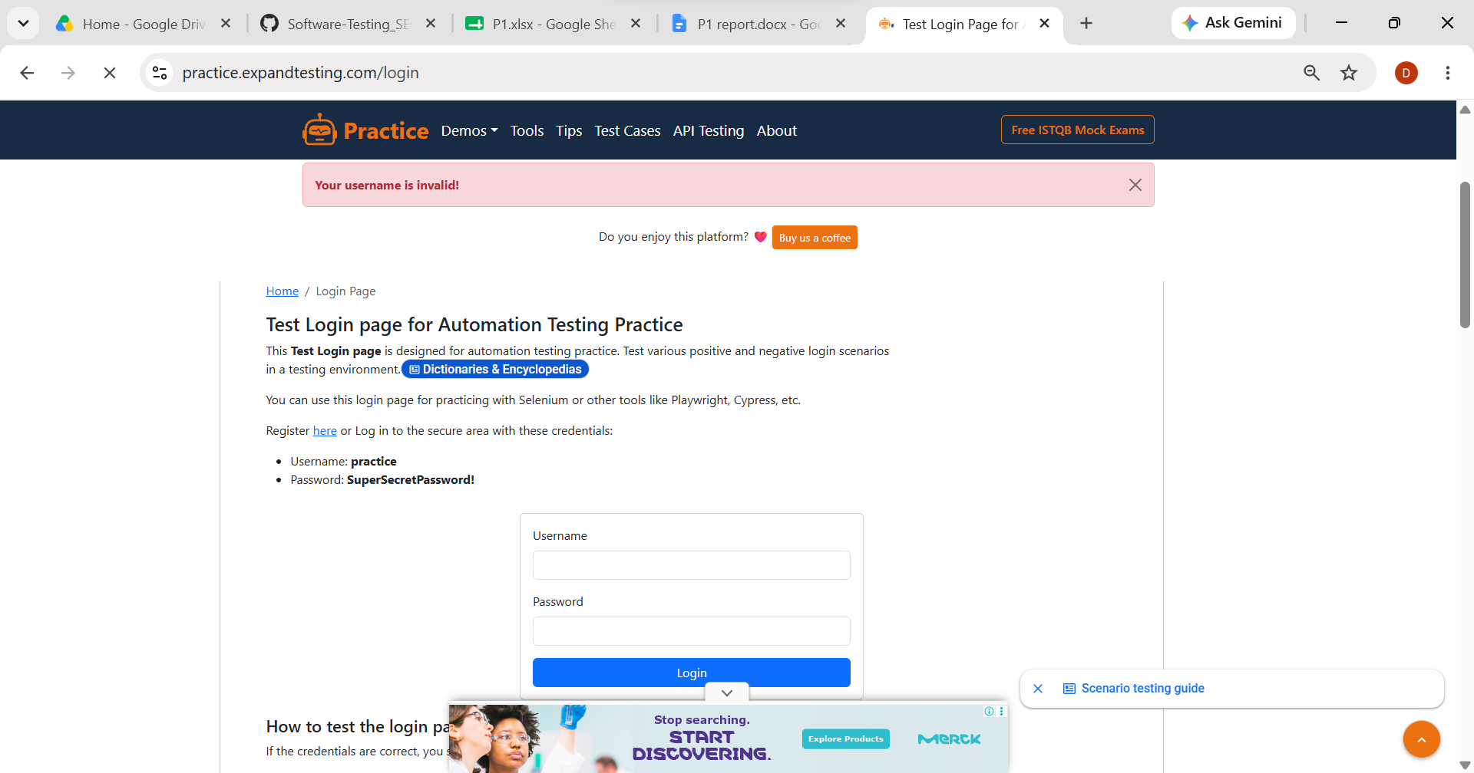

- Scenario ID: 1f
- Scenario:Login with empty username
Test step:

1.Leave username blank
2.Click on login
Screenshot:

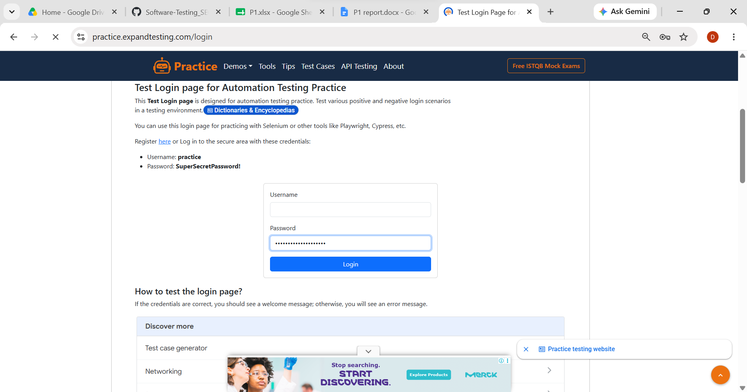

- Scenario ID: 1g
- Scenario:Login with empty password
Test step:

1.Leave password blank
2.Click on login
Screenshot:
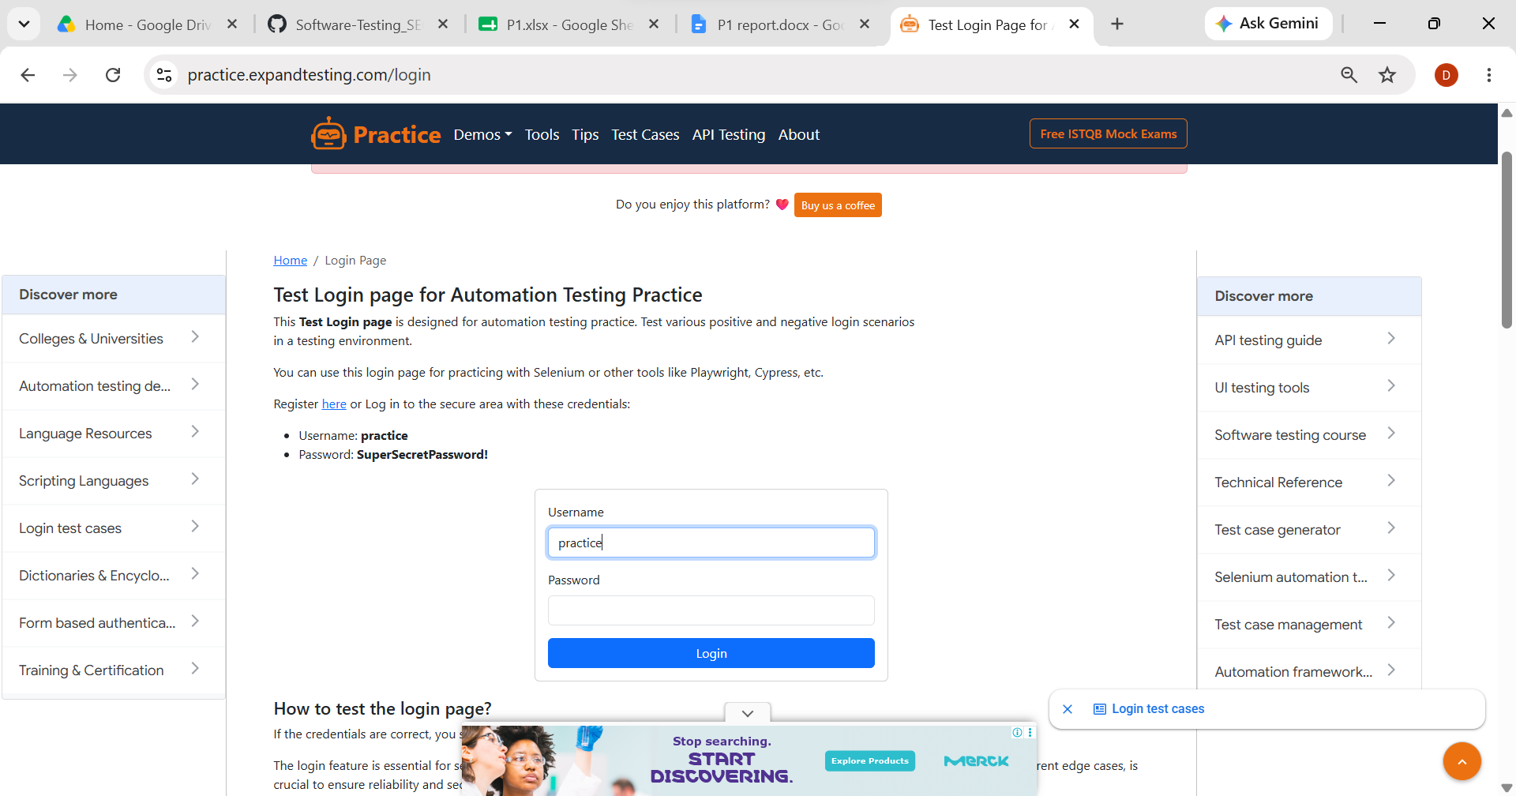
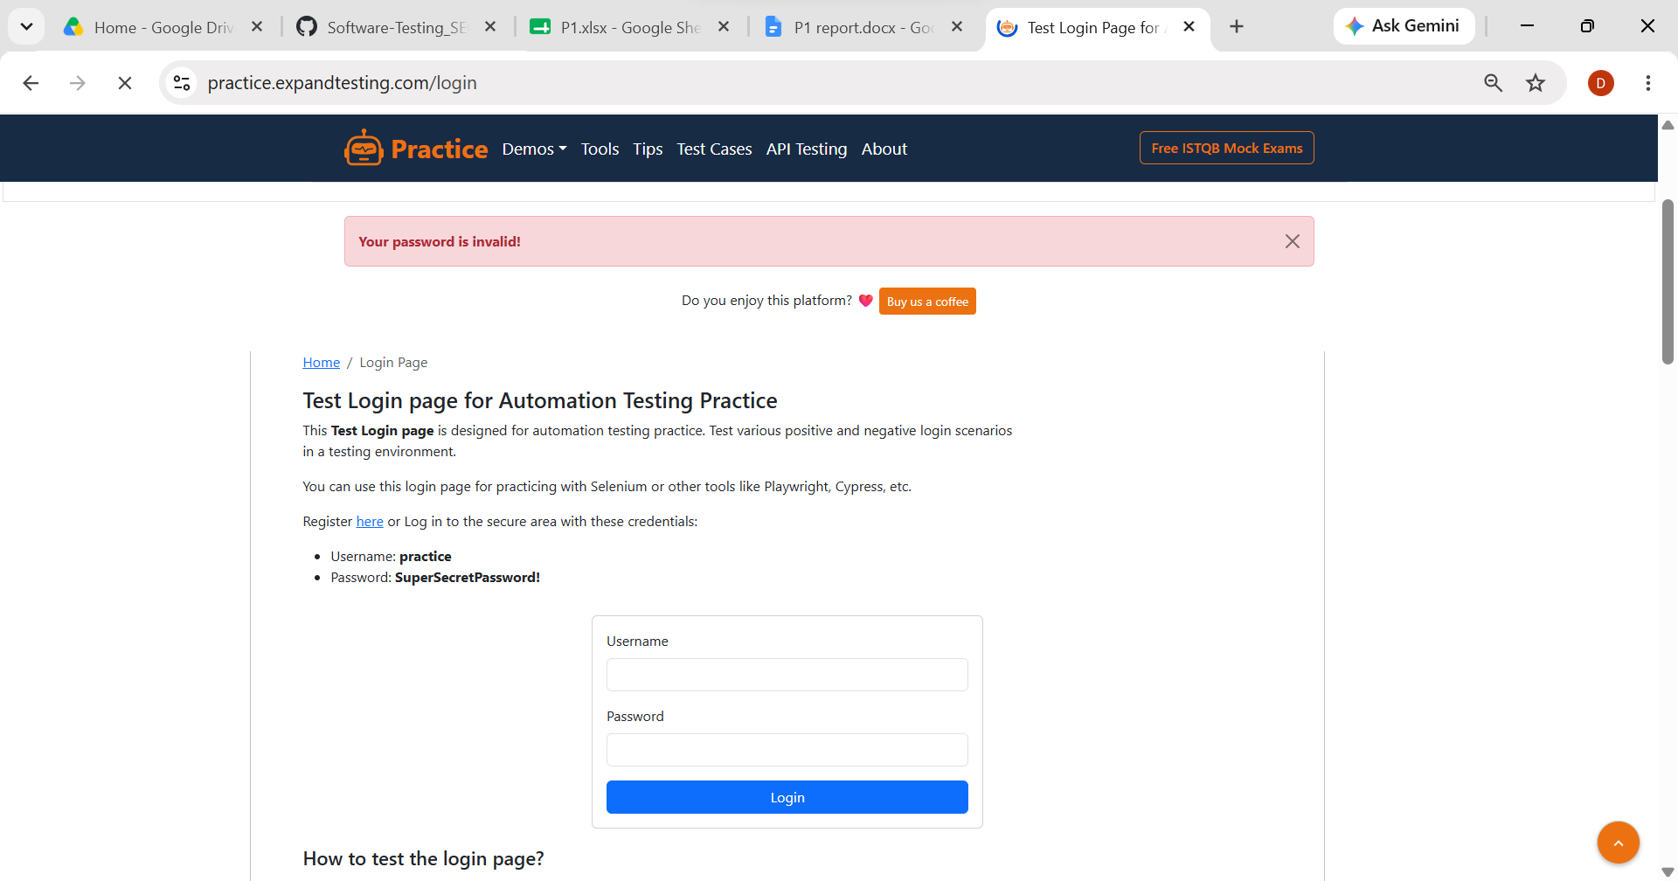

- Scenario ID: 1h
- Scenario:Login using spaces
Test step:

1.Enter spaces before/after username/password
2.Click on login
Screenshot:

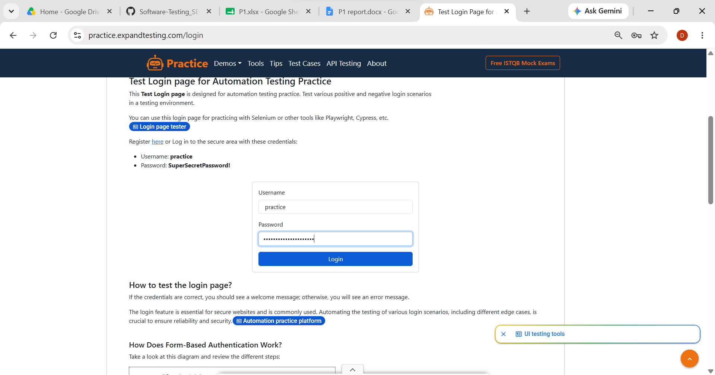

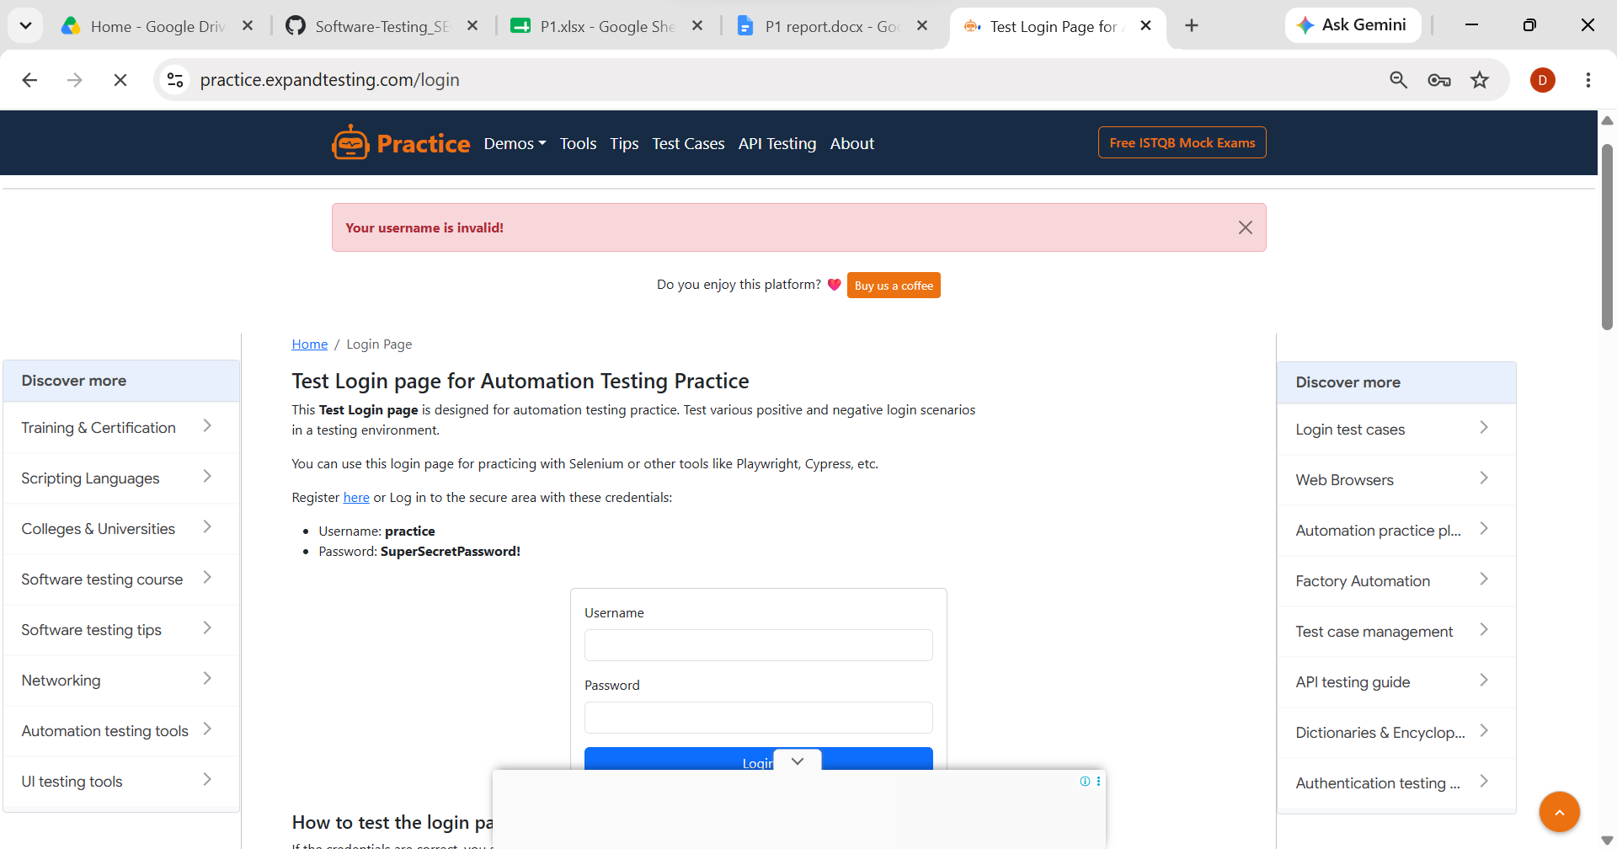

- Scenario ID: 1i
- Scenario:Verify password masking
Test step:

1 Type password in the Password field.
2.Verify that the password is hidden with dots (●●●●).

Screenshot:
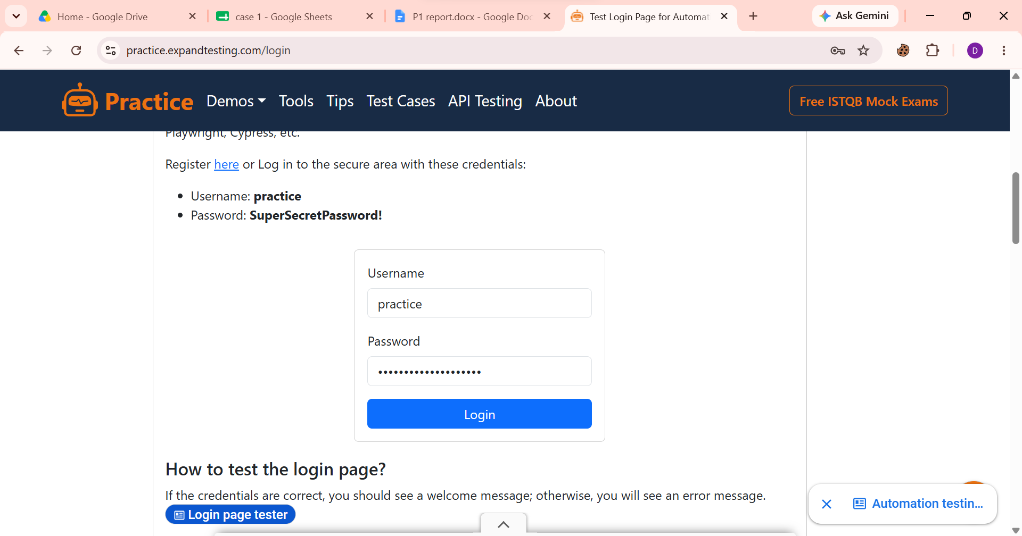

- Scenario ID: 1j
- Scenario:Login using Enter key
Test step:

1.Enter valid credentials
2.Press Enter
Screenshot:

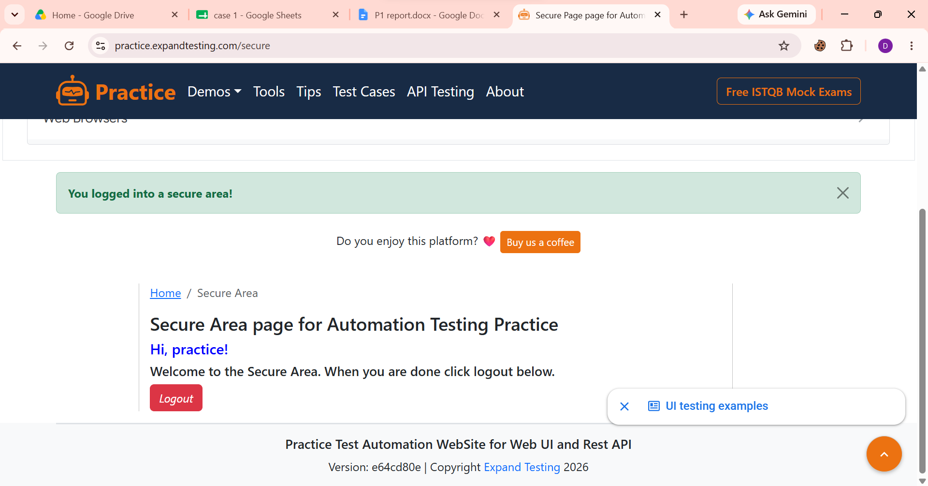

- Scenario ID: 2a
- Scenario:Logout after successful login
Test step:

1Login successfully
2.Click Logout
Screenshot:
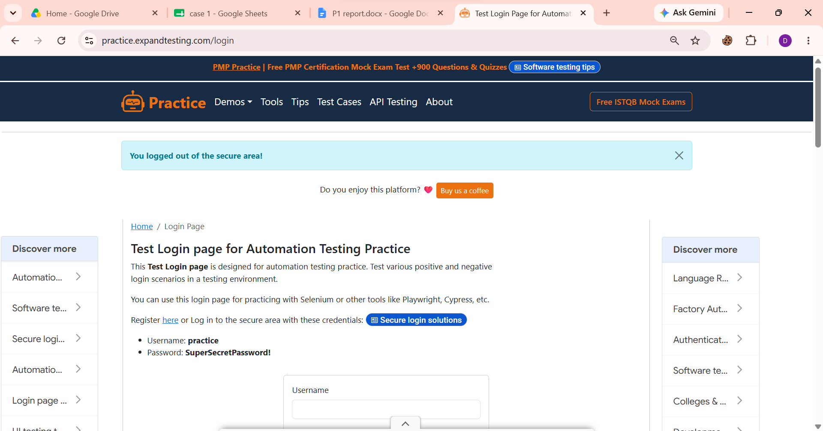

- Scenario ID: 2b
- Scenario: Browser Back after logout
Test step:

1.Login successfully.
2. Click logout.
3. Press the Browser Back button.
Screenshot:
- Scenario IDs: 3a to 3h
- Scenario:
- 3a: Verify Username Field
- 3b: Verify Password Field
- 3c: Verify Login Button
- 3d: Verify Username and Password Labels
- 3e: Verify Responsive Layout
- 3f: Verify Keyboard Tab Navigation
- 3g: Verify Button Alignment
- 3h: Verify Error Message Display
Screenshot for scenarios 3a -3h

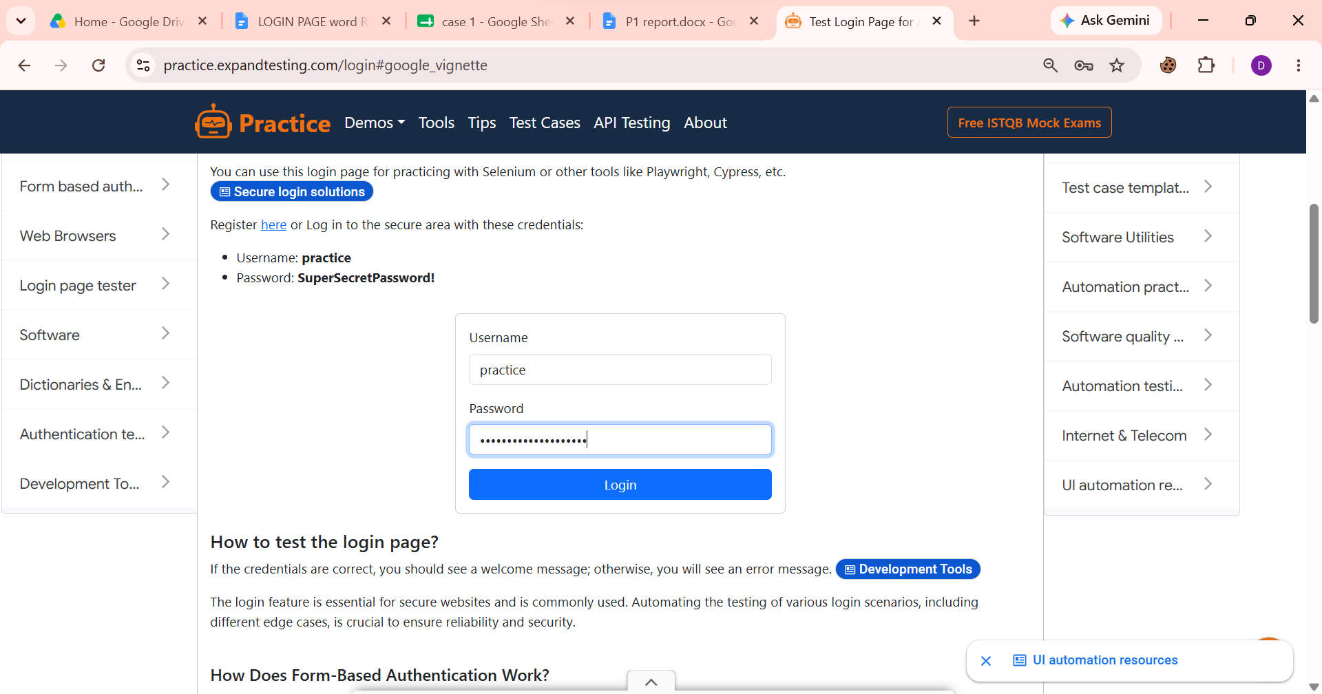
conclusion :
All functional and UI test cases for the Login Page were executed successfully. The application behaved as expected, and all test cases passed. The login functionality, validations, UI elements, and session handling were verified successfully.

